Nama : Bagus Fadilah Ahmad

NIM : 18090008

Kelas : 5D

PRAKTIKUM 2

1. Source Code

latihan1-> application/controller

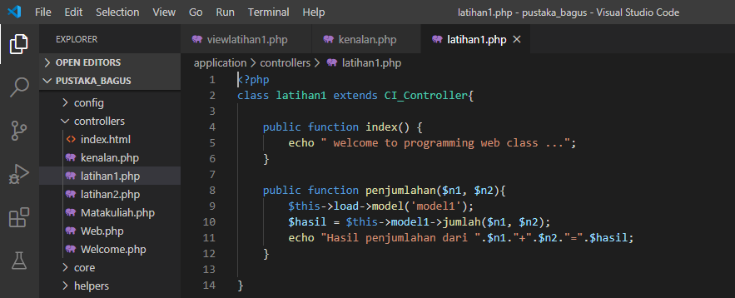

latihan2 -> application/controller

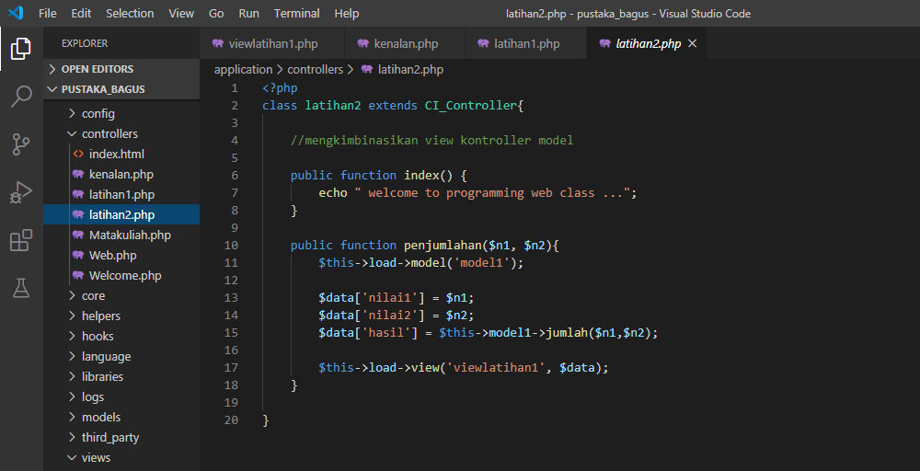

model1 -> application/model

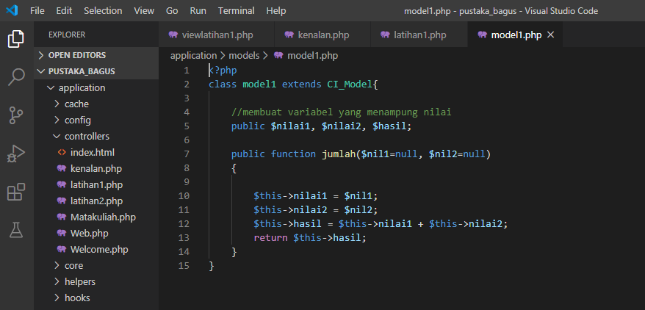

viewlatihan1.php->application/view

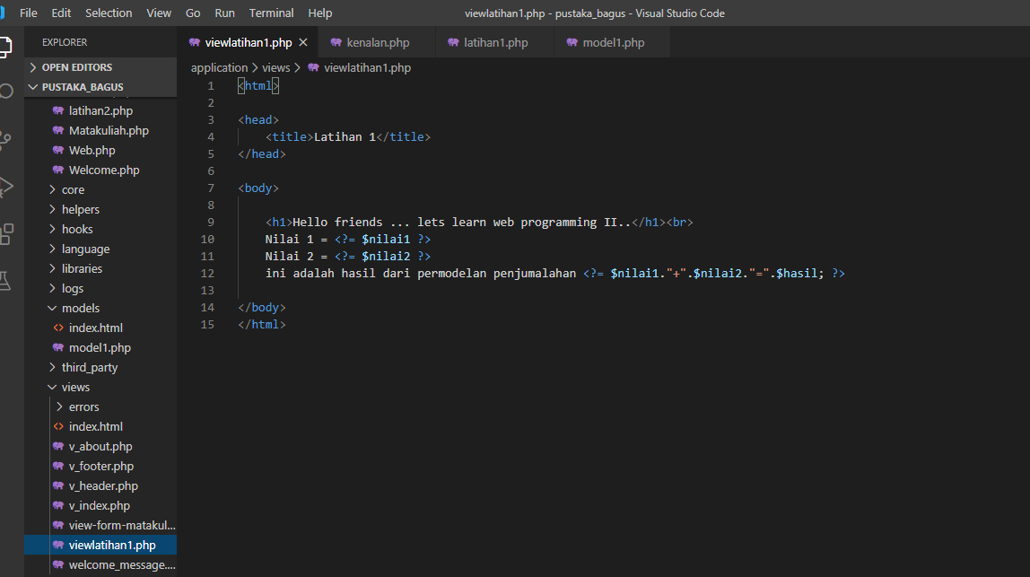

1. URL

<http://localhost/pustaka_bagus/index.php/latihan2>

[http://localhost/pustaka_ bagus /index.php/latihan2/penjumlahan/1/6](http://localhost/pustaka_haniff/index.php/latihan2/penjumlahan/1/6)

[http://localhost/pustaka_ bagus /index.php/latihan1/penjumlahan/4/5](http://localhost/pustaka_haniff/index.php/latihan1/penjumlahan/4/5)

1. Capture Hasil

**Hasil run latihan 2**

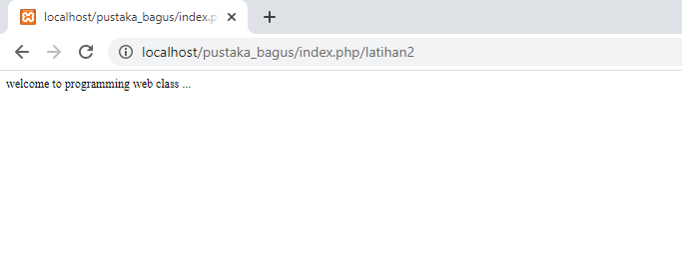

**Hasil run penjumlaha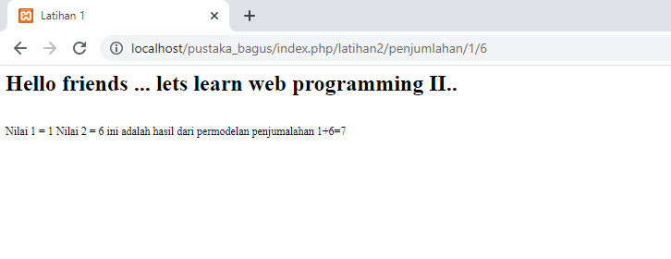Hasil run latihan 1**

